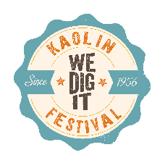

2023 Kaolin Festival Sponsorship

Festival Presenter
$2,200
- Banner to display on site at festival
- Float registration fee waived
- Recognition on all marketing: print, social media and radio

Platinum Sponsor
$1,250
- Banner to display on site at festival
- Recognition on all marketing: print, social media and radio

Gold Sponsor
$750
- Gold Sponsor yard sign to display on site at festival
- Recognition on all marketing: print, social media and radio

Silver Sponsor
$450
- Silver Sponsor yard sign to display at business
- Recognition on all marketing: print, social media and radio

Bronze Sponsor
$250
- Recognition on all marketing: print, social media and radio

Friend of the Festival
$100
- Recognition on all marketing: print, social media and radio

Specific Sponsorship Opportunities

Entertainment Sponsor
$1000
- Banner to display on site at festival
- Recognition on all marketing: print, social media, and radio.
Car Show Sponsor
$1000
- Banner to display on site at festival
- Recognition on all marketing: print, social media, and radio.

Kid Zone Sponsor
$1000
- Banner to display on site at festival
- Recognition on all marketing: print, social media, and radio.

Sponsorship/Donation Information:
Please complete the below information and enclose it with your donation to:
Washington County Chamber of Commerce,
603 South Harris Street, Sandersville, GA 31082

Business: _______________________________________________________________
Contact Person: __________________________________________________________
Mailing Address: _________________________________________________________
Telephone: ______________________________________________________________
Donation Level: ____________________________________________

Deadline for sponsorship is June 30th, 2023

