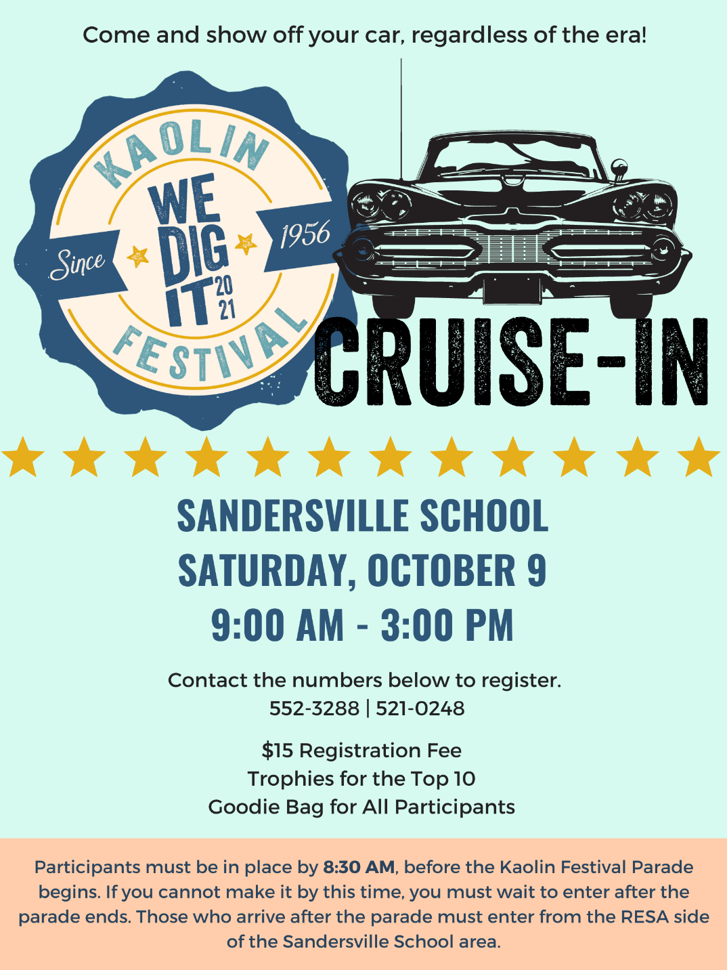
Kaolin Cruise-In

Name: ______________________________
Address: ____________________________
______________________________
______________________________
Phone Number: ______________________
Email: ______________________________

Vehicle Information:
Year: _______________________________
Make: ______________________________
Model: _____________________________

Thank you for joining us!
Wade Dawson

